



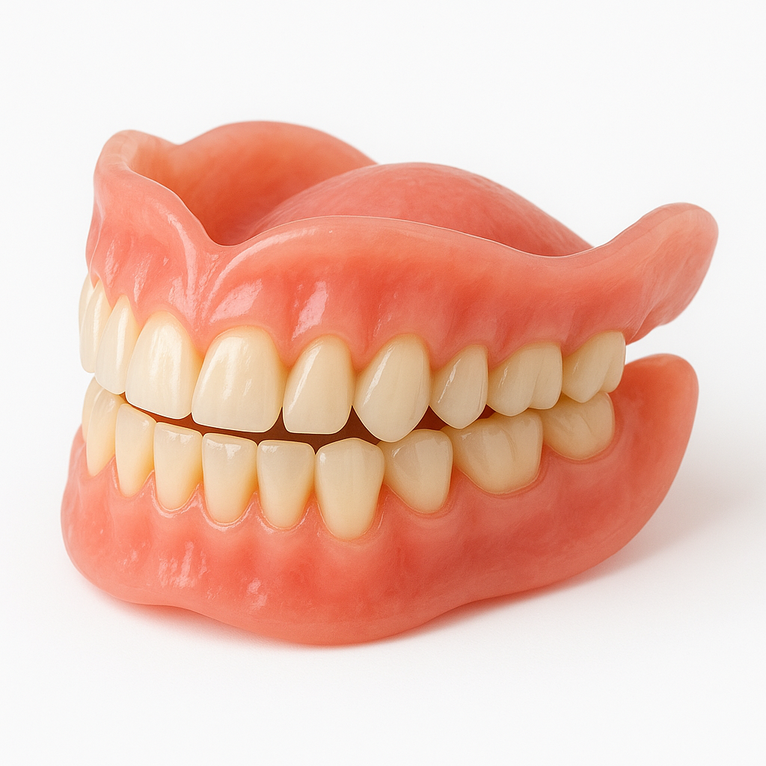
Dentures

Surrey Community Dental Service


What is a denture?
A denture is a removable replacement for missing teeth and surrounding tissues. They can be full (replacing all teeth) or partial (replacing a few missing teeth).
Different Types of Dentures
Dentures come in various types, depending on your needs. Here's a breakdown to help you understand your options:
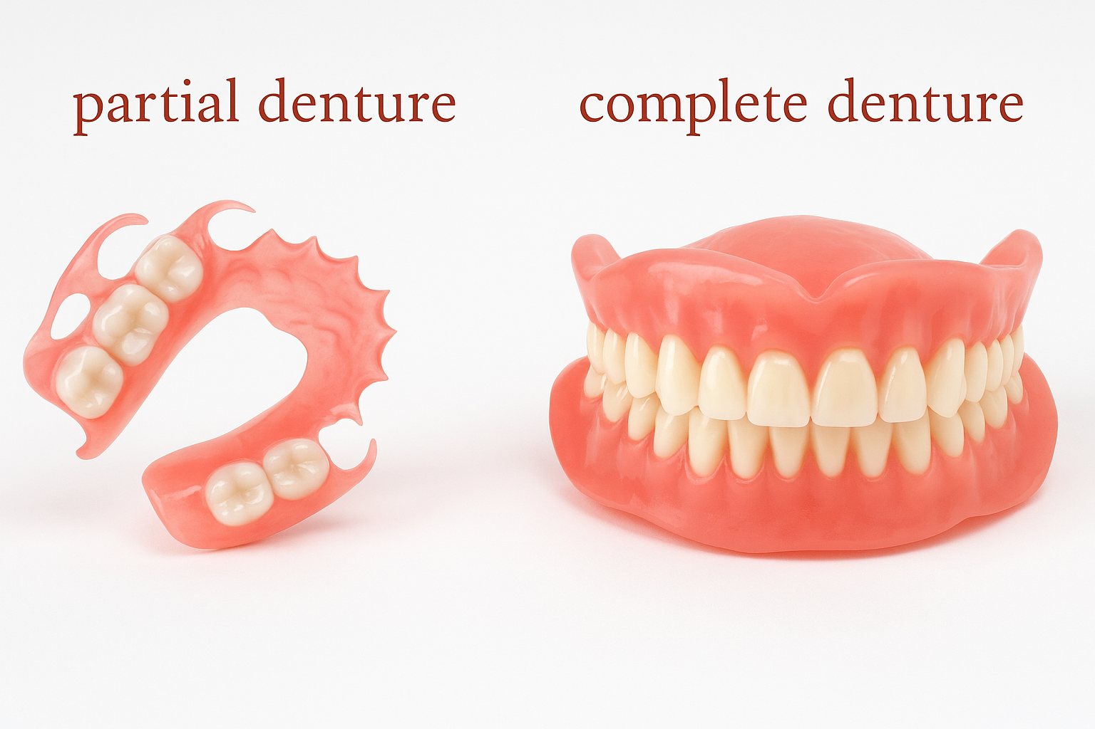
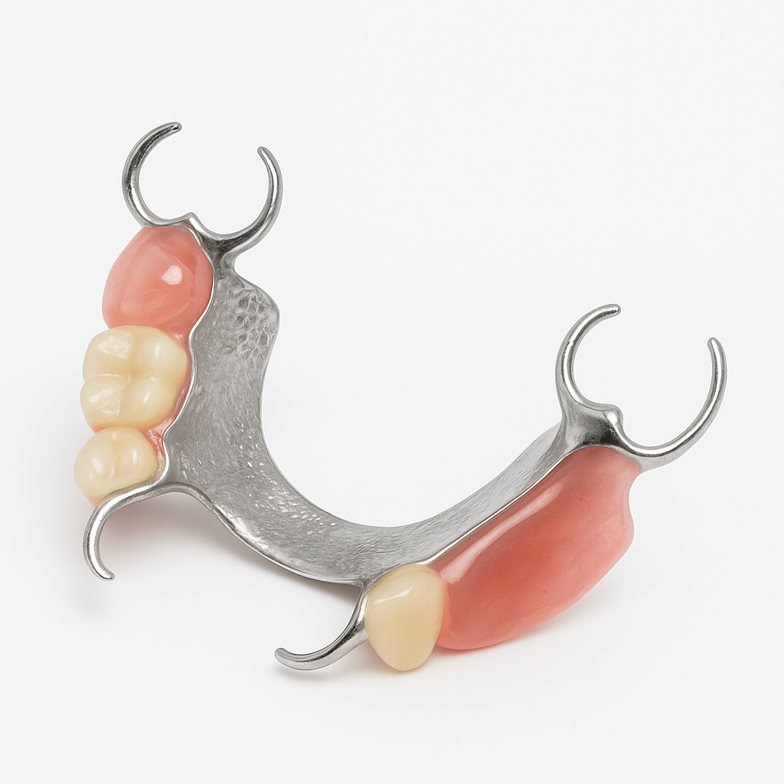
Full Dentures (Complete Dentures)
- Replace all teeth in the upper or lower jaw (or both).
Partial Dentures
- Used when some natural teeth remain.
- Made from acrylic or metal frameworks with clasps to hold onto natural teeth.
Immediate Dentures
- Placed immediately after teeth are removed.
- Allow you to have teeth right away but may need adjustments as your gums heal.
- Often replaced later with a permanent denture.

Benefits of Dentures
- Dentures improve appearance and confidence by replacing missing teeth.
- They help maintain the shape of your face and prevent the sunken appearance that can follow tooth loss.
- With practice, dentures can restore your ability to chew a wide range of foods.
- They help correct speech difficulties caused by missing teeth.
- Dentures are generally more affordable and accessible than alternatives like implants.
- No surgery is required, which may be ideal for older adults or those with medical conditions.
Why Some People Struggle with Dentures
While many people adjust well, some patients may find dentures challenging due to:
- Gag Reflex Sensitivity: Especially with upper dentures that cover the roof of the mouth.
- Poor Retention in the Lower Jaw: Lower dentures can move more due to less bone support and tongue movement.
- Dry Mouth (Xerostomia): A lack of saliva can affect denture suction and comfort.
- Allergies or Sensitivities: Some may react to acrylic materials used in dentures.
- Difficult Bone or Gum Shapes: Severe bone loss or uneven gums can make achieving a stable fit difficult.
- Personal Comfort: Some patients simply feel unnatural wearing a removable appliance.
- Frustration with Adaptation: Adjusting to speaking, chewing, and cleaning can take time and patience.

Are dentures my only option?
No, your dentist can help you explore the best solution for your needs and budget. Some treatment options may only be available privately.

Stages of Making a Denture
Creating a denture involves several important steps. Here's what to expect:
1. Initial impressions (Moulds) are taken. These helps create a precise model of your mouth.
2. Second Impressions (Moulds) and Bite Registration -Your dentist records how your jaws come together (your bite).
3. A trial denture (usually in wax) is made to test fit, comfort, and appearance. You’ll see how the denture looks and feels before the final version is made. Adjustments are made based on your feedback.
4. Your finished denture is fitted and checked for comfort and function. The dentist ensures it fits snugly and looks natural. You may need follow-up visits for minor adjustments.

This is an estimated timeline. Additional appointments may be required.

It’s normal to feel some discomfort at first – your dentist can smooth out any sore spots.
Long-Term Care
Over time, your mouth may change shape. Relining or replacing the denture may be needed. Regular dental visits help keep your denture and mouth healthy.
How long will my dentures last?
With proper care, dentures typically last 5–8 years. Over time, they may need relining, adjustments, or replacement due to changes in your mouth.
