


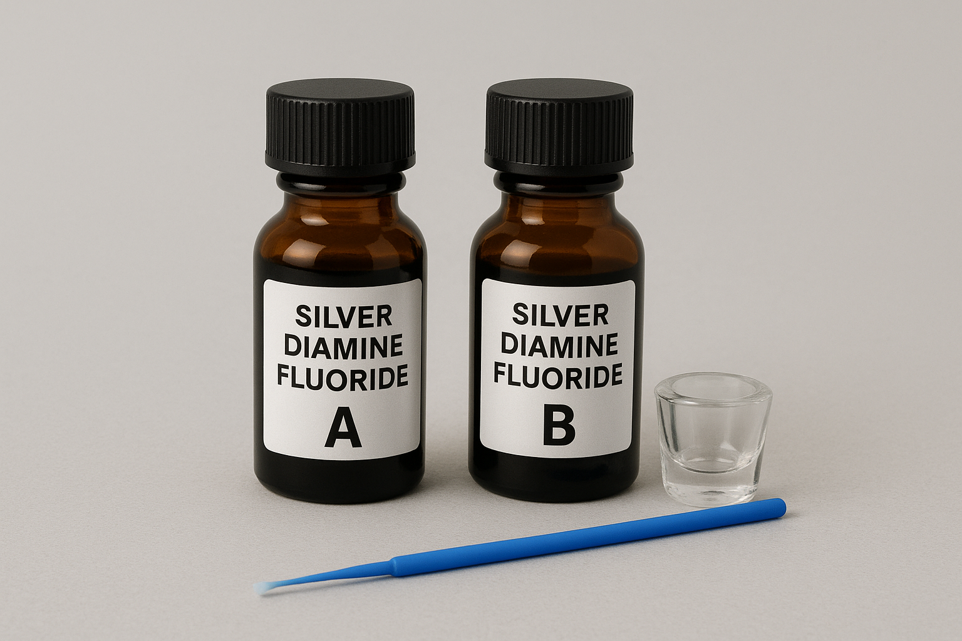
Silver Diamine Fluoride
(SDF)

Surrey Community Dental Service
What is Silver Diamine Fluoride?
- SDF is a clear liquid that contains silver and fluoride which work together to stop decay progressing further.
- It has a temporary metallic taste which disappears soon after being painted on the teeth.

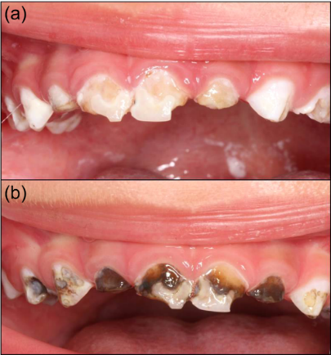
What are the advantages of SDF?
- Dental decay can progress rapidly, especially in baby teeth which have thinner enamel than adult teeth. SDF liquid is simple to apply and can stop decay progressing, which will reduce the risk of toothache or infection.
- It is particularly helpful for both adults and children who are unable to manage other dental treatment.

The use of SDF needs to be combined with improved oral hygiene and a change in diet to save the teeth.

What is involved in the treatment?
- To protect the lips and gums, your dentist will first apply petroleum jelly (or an alternative) and place a cotton wool next to the teeth. The teeth will then be dried.
- The SDF liquid is painted on to the teeth for 1-3 minutes. Following this the teeth are dried a second time. Sometimes, the dentist may then place a filling over the top.
- This is all done in one appointment. A second appointment may be made to comeback 6 weeks later to check the teeth and apply more SDF liquid if needed.

What are the disadvantages of SDF?
- SDF can temporarily stain the skin, lips, gums and cheeks brown or white for 1-3 weeks, this will then disappear.
- SDF permanently discolours the decay black. Healthy parts of the tooth do not discolour. It can also discolour tooth-coloured fillings.
- In the unlikely event of SDF being accidentally spilled on clothes, it can leave a stain that does not come out.

If the SDF does not stop the decay progressing, an alternative treatment may be required

What are the alternatives?
- Monitoring the tooth, but it is likely the decay will get worse
- Placing fluoride varnish (although this is not usually as effective)
- Filling the tooth
- Placing a silver cap/crown
- Removing the tooth

SDF cannot be applied if:
- The patient has an allergy to silver or any other heavy metal or ingredient
- The patient has painful gums, ulcers or sores in the mouth at the time of treatment
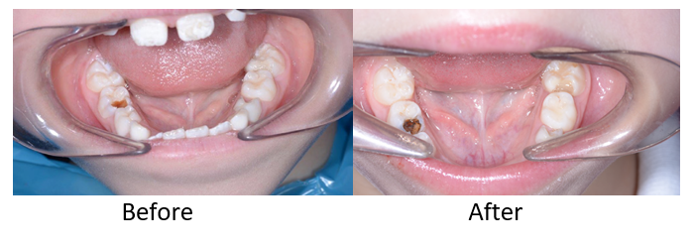

Review 08/202

